R&D Parallax & CubeMapping Effect Guide

# Parallax

For the parallax set up I have the

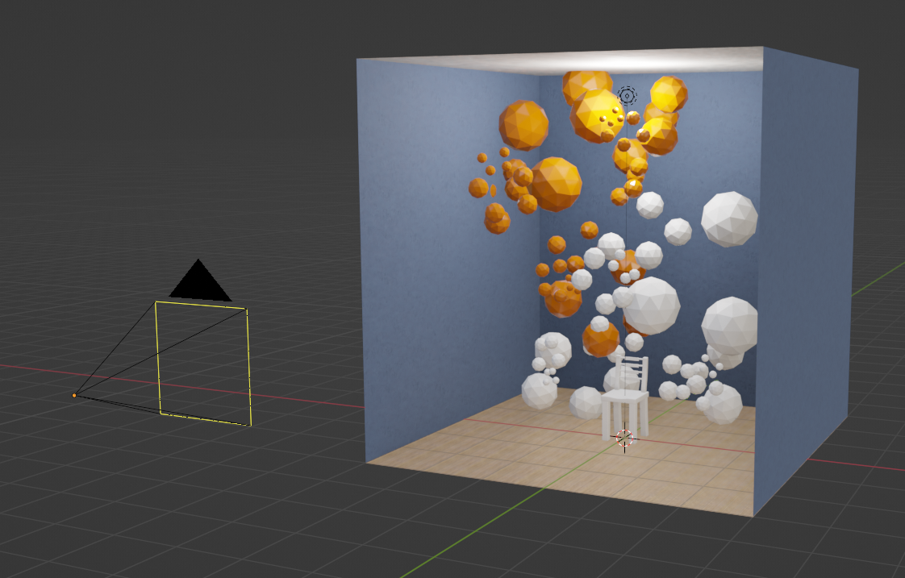

For the geometry of your scene I used a cube missing one face to render the camera although a similar effect can be used with backface culling enabled.

Place your objects into the scene. It can be set up in any way, as long as you try to keep big objects from blocking the front, it won’t break but will likely not have as nice of an effect.

Next are the settings for the camera:

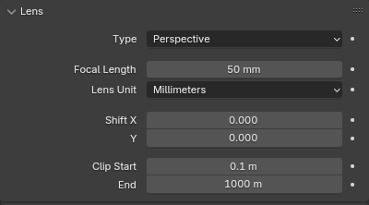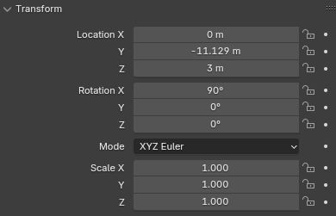

For the setup of my camera I’ve positioned it a short distance away and used the perspective view to adjust the focal length until I could get as much of the interior into shot.

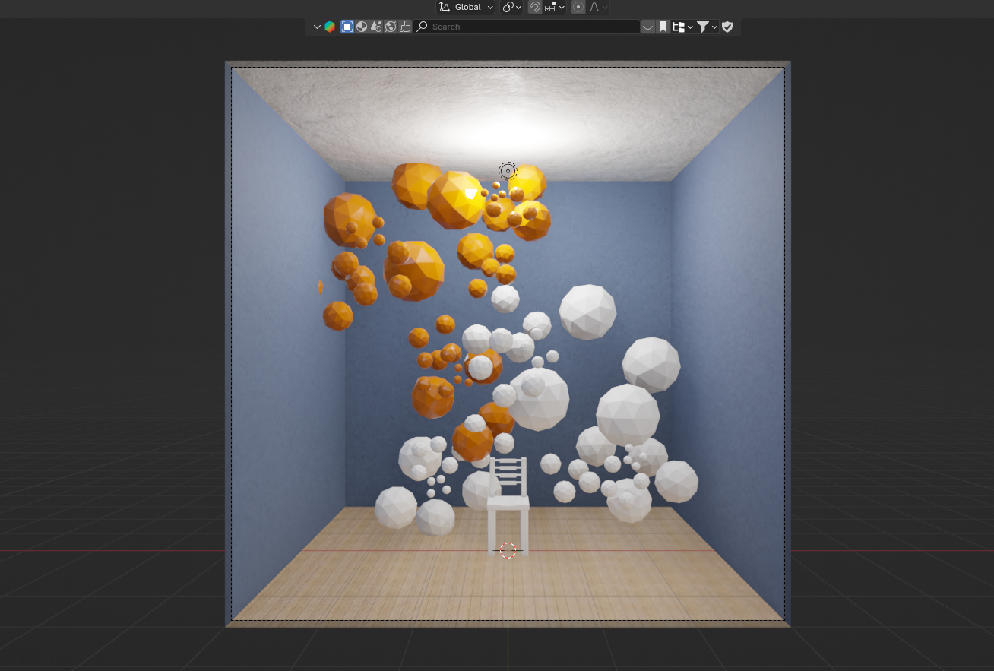

At this point the R&D_Render_Textures code can be copied into blenders text editor, if you can’t find it it is located at the top here:

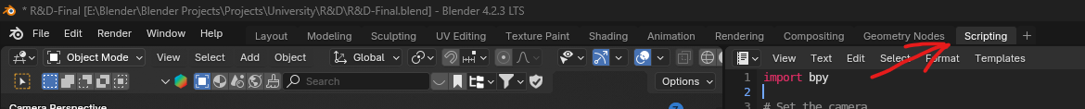

Now you need to replace “Camera.008” with the camera you’ve set up.

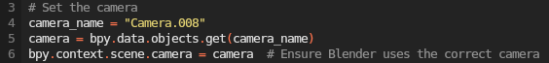

You also need to replace all the directory paths with whatever location you want the file to be saved to and keep the .png files name the same to avoid conflict and compatability.



Now you should be able to render out your textures with just a click of the button at the top.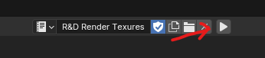

This is roughly what your render files should look like:

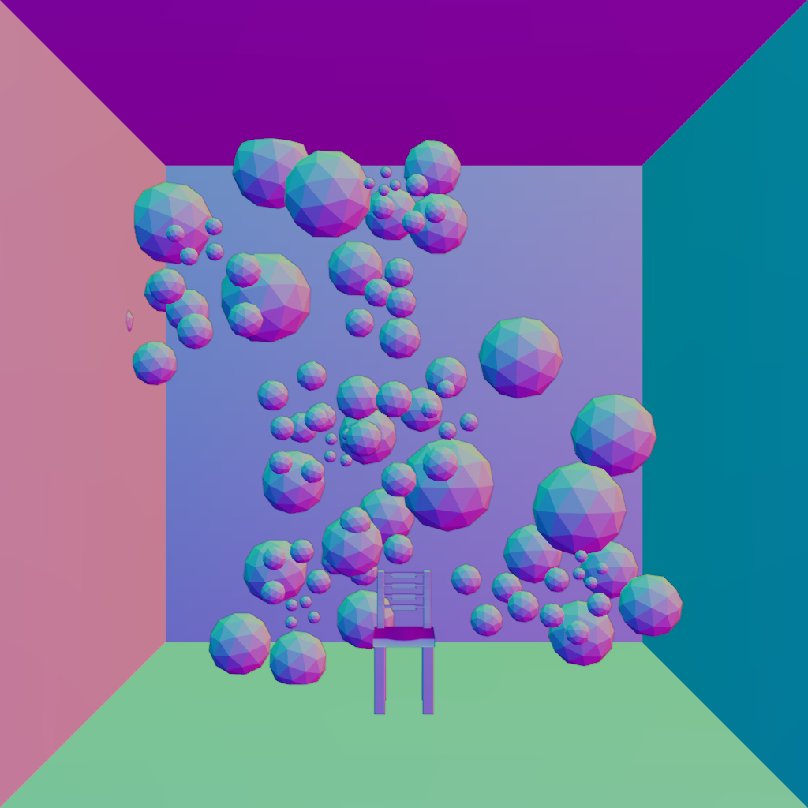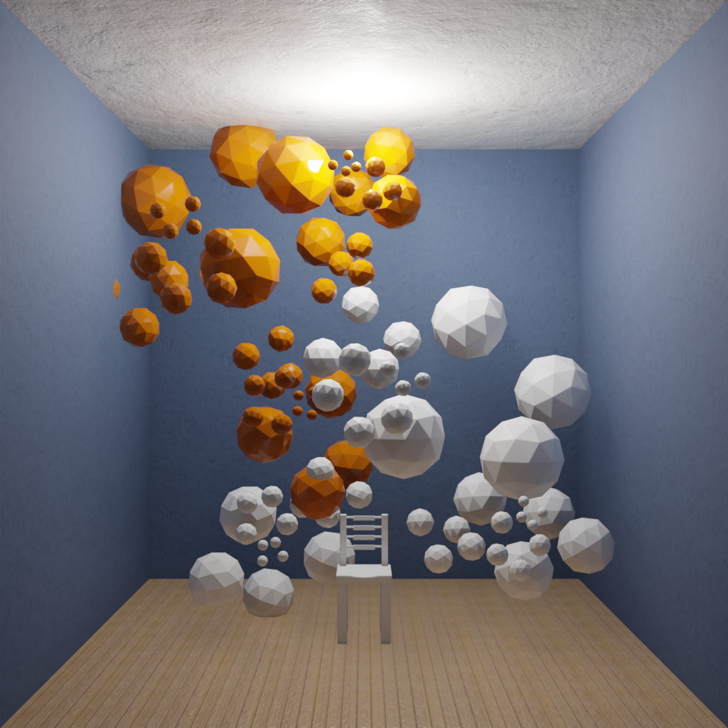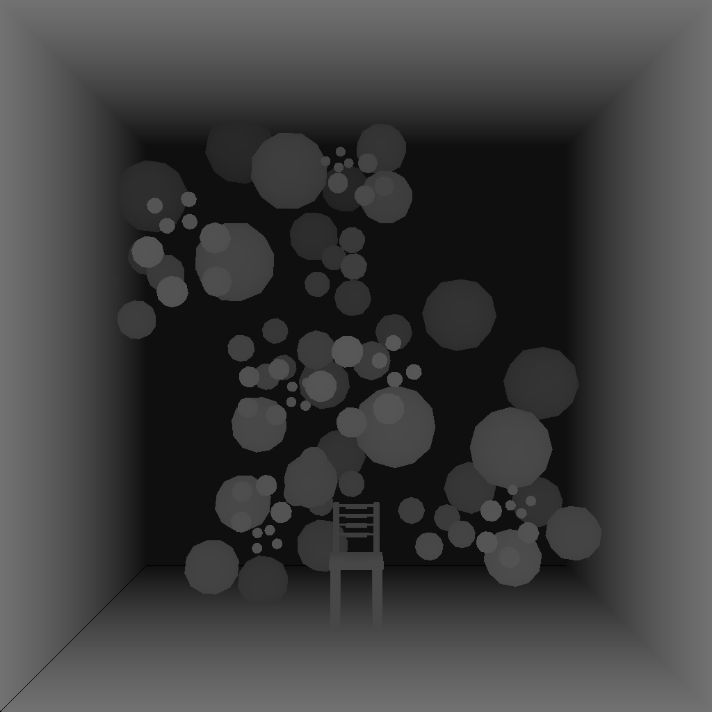

Normal ^ Colour ^ Depth ^

At this point you now have the basic textures required for a parallax shader and for the sake of brevity and as there are many tutorials about them online including this one: <https://youtu.be/WNXPaAnxlQQ?si=yQUbZRGmQDKIu9a_>

Although if you want to replicate what I did here is the blueprint layout for the material:

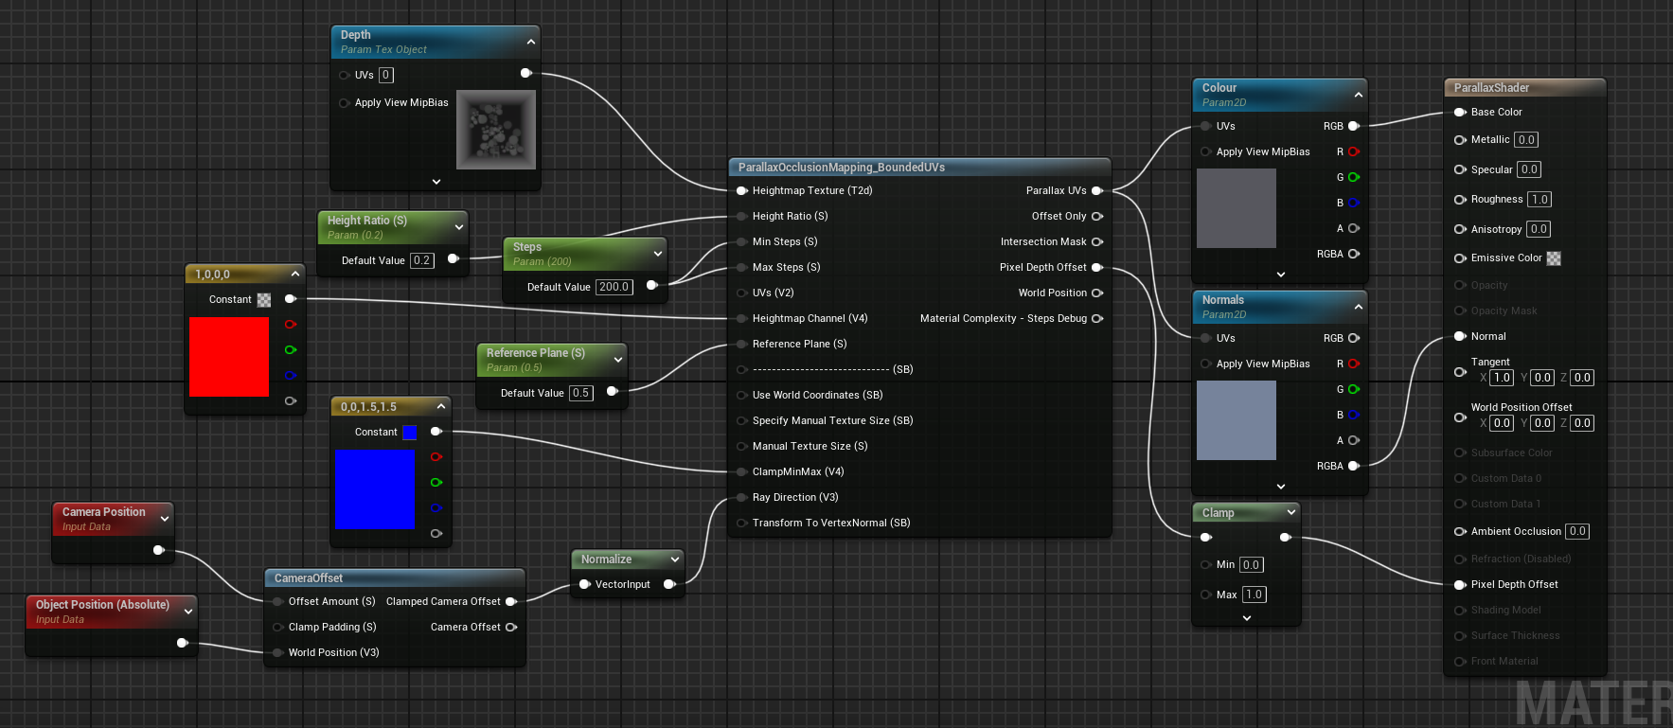

This should be the result:

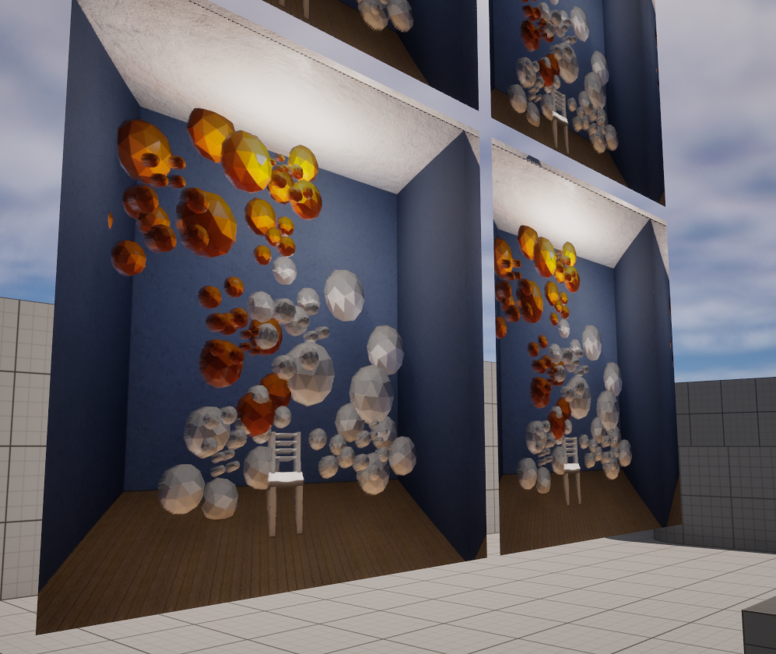

# CubeMapping

## Blender

Skip if you want to use unreal or want a equirectangular map.

For this one you must copy and paste Cube_comp and Cube_render into separate blender text files like with parallax. Also change any directory locations and the camera name to the one being used.

To set up the scene you need a camera with these attributes:  
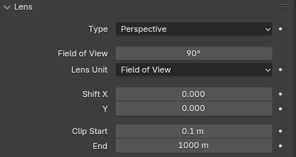

It needs to be located in the centre of the cube.

Now you should be able to run the Cube_render code and have each face of the cube rendered to a texture.

The next step is running the Cube_comp code, this will utilize blenders in built compositor to composite the 6 textures onto just one creating a simple cube map. you go to the compiler tab and hit render or “F12”.

Like these:

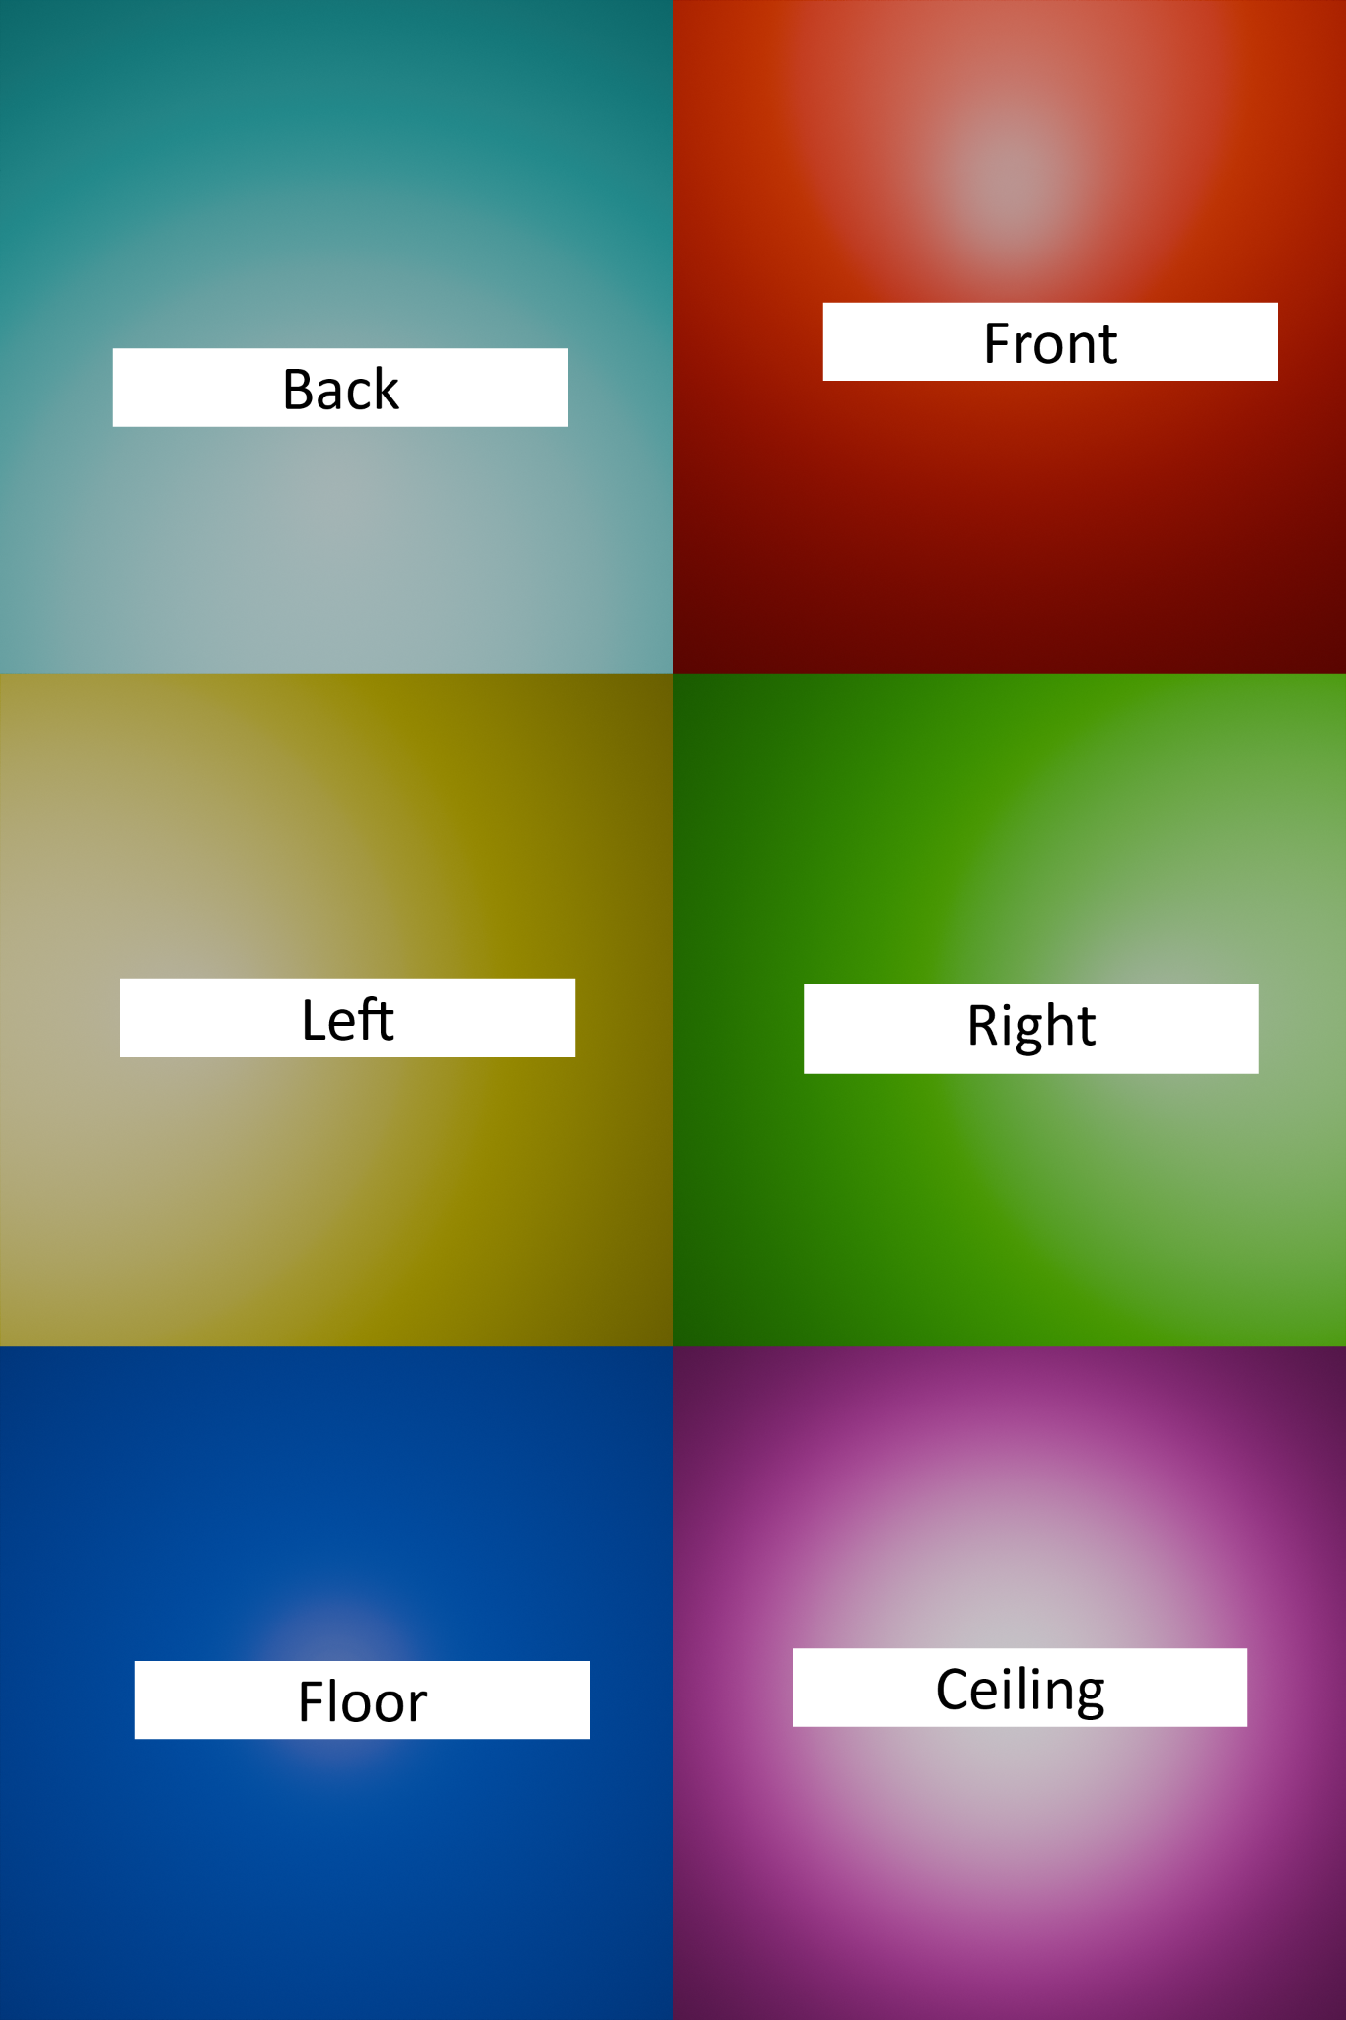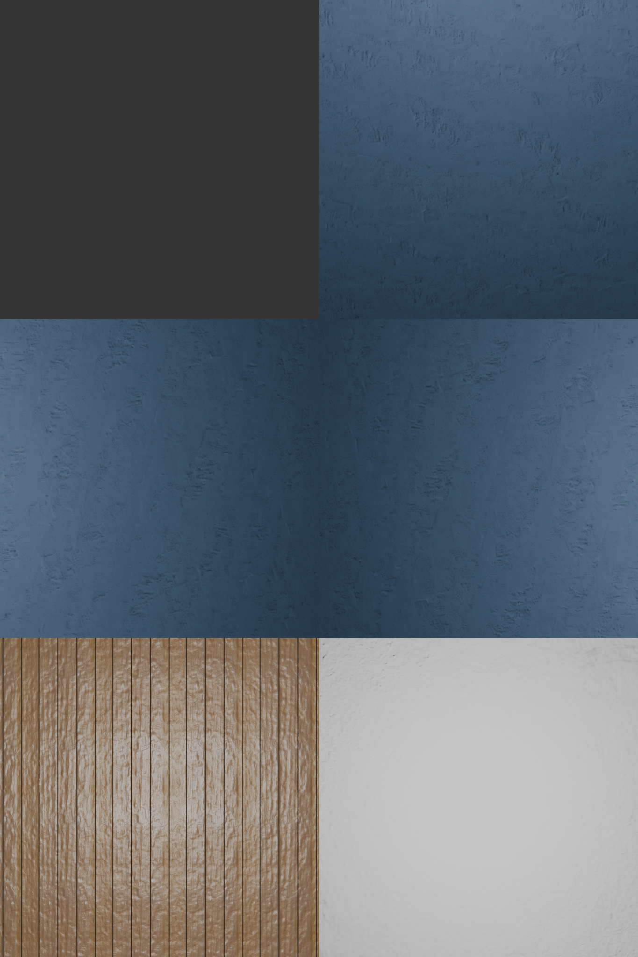

## Unreal

For this part I will be using unreal engine for its ease of use although there are other methods for creating a cube map.

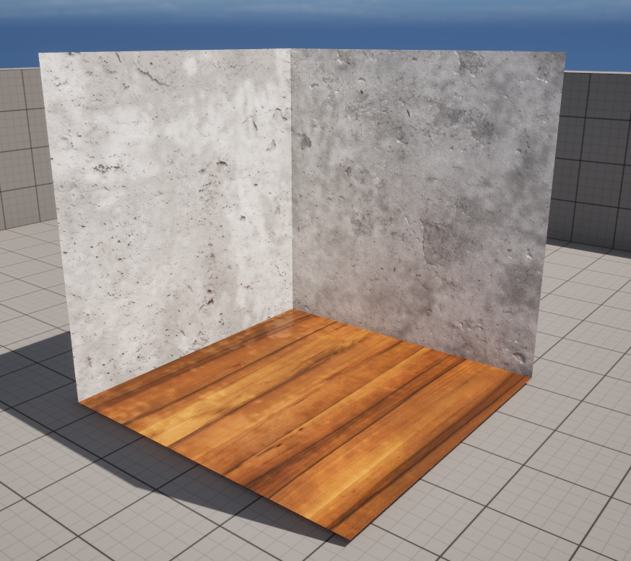

First create a cube, this will be your room. Feel free to set the materials however you like although to work you need to have the walls, floor and ceiling separated.

You also need to make sure the normals are facing inside or your materials are double sided.

In the files there should be a file R&D-TEST-8.obj this is one already set up to drag into unreal.

Once that's done place a scene capture cube and point light into the exact center of the cube

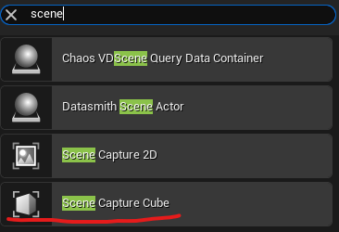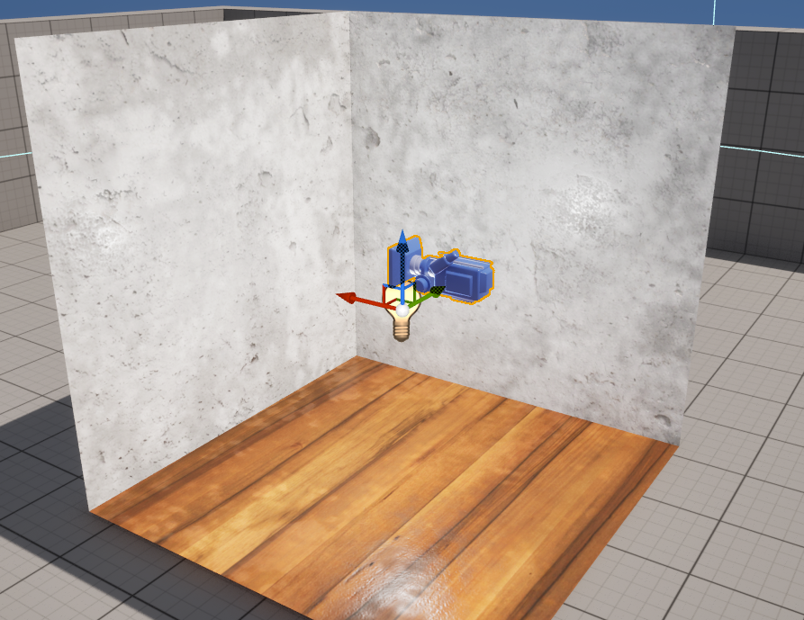

With the SceneCaptureCube in selected we can select a texture target: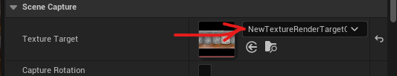

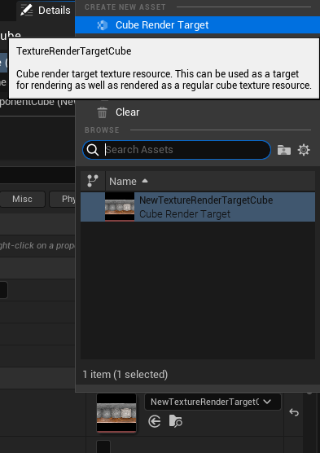

Select Cube render target you will then be asked to save asset as, select it’s storage location, name it and click save.

Now you can create the material, first start with a basic material by right clicking on the blank space in the content drawer, a menu should pop up, select material.

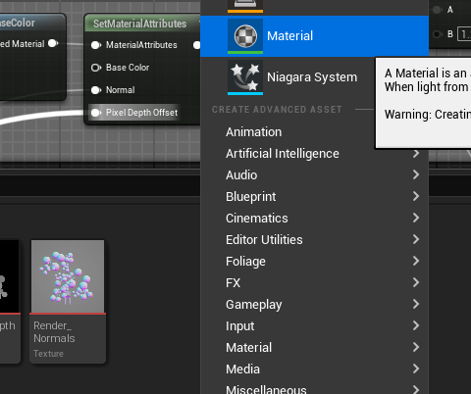

This is the node layout for the equirectangular cubemap set up:

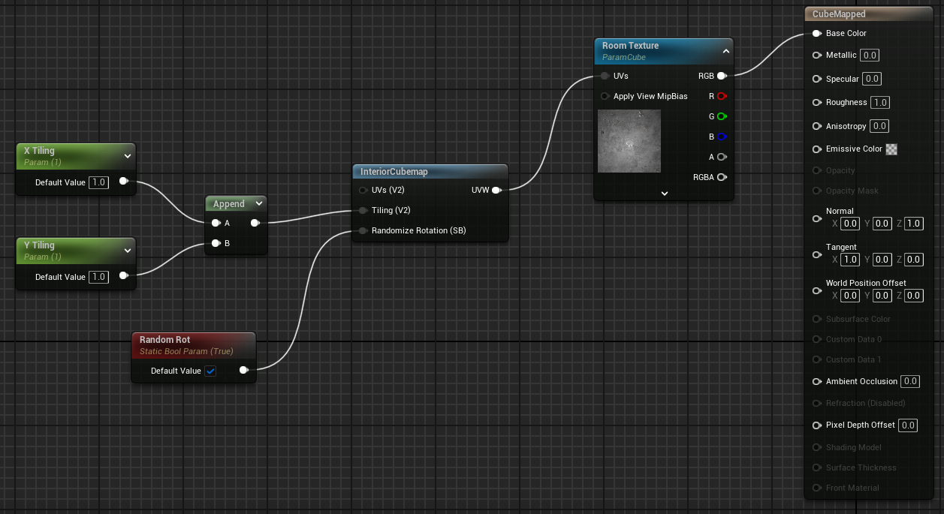

# Parallax & CubeMapping

Now you have the parallax and cube map set up you should be able to set up the rest, a few tweaks were made to the parallax map settings and the depth map gets used to create the mask for blending both materials.

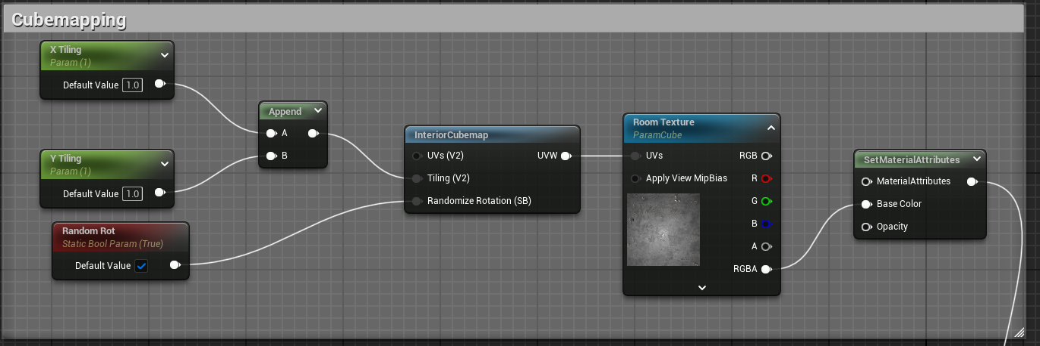

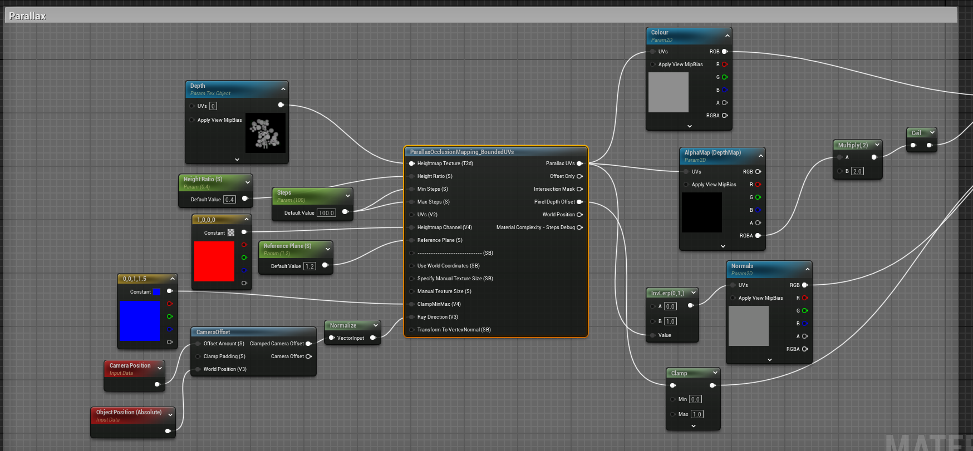

For my material because I didn’t create an alpha map, I multiply the depth map then use the ceil function so each pixel is either black or white, creating an alpha mask for the OverrideBaseColour node.

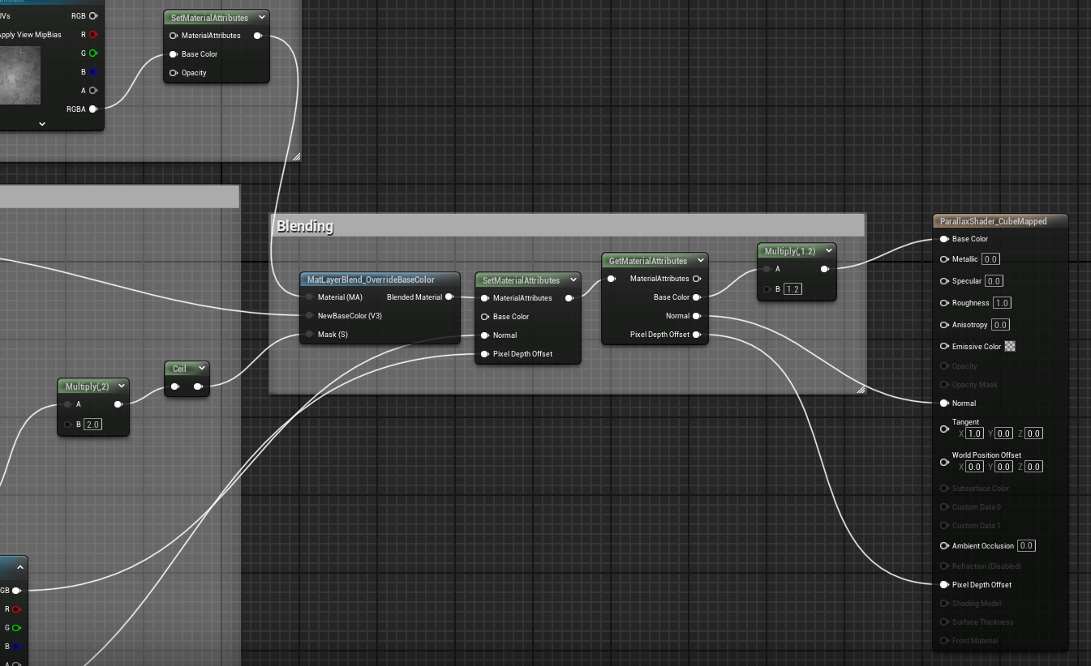

# Finished

Ok now that the shaders are set up I suggest playing with some of the parameters, especially on the parallax.